NUCLEAR BLUES RESOURCE

Bob Dylan’s Subterranean Homesick Blues is said to be written about living underground after the bomb is dropped.

D.A. Pennebaker filmed this Dylan tune for the film Don’t Look Back and Allen Ginsberg can be seen in the background dressed as a Rabbi.

We’ve recorded a track with new words that you can use to film your own version of this iconic video.

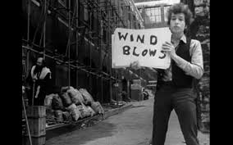

Here is a link to the musical track for Nuclear Blues.

Write your own cue card’s a la Allen Ginsberg, Bob Neuwirth, Donovan & Dylan himself.
Use 14” x 18’ Poster board or smaller.

Go to school on DYLAN’S VERSION or use your imagination and create your own

Gather your crew, grab a phone, film it & then post on the NUCLEAR BAN DAYS OF ACTION facebook page.

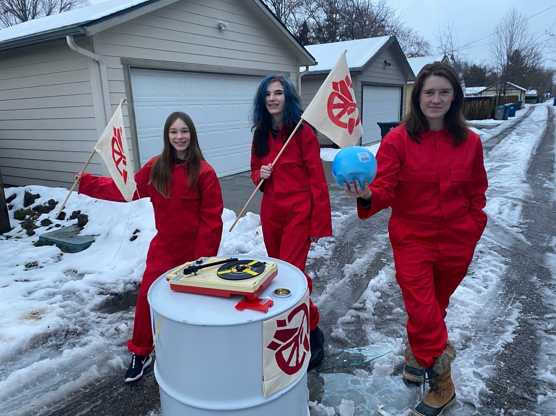
SNAKE RIVER ALLIANCE // BOISE IDAHO

